**Counting activities for Nursery children**

Development matters statements for number are below. An average child should be secure in all the statements by the end of the year.

|  |  |
| --- | --- |
| Nursery | Reception |
| |  | | --- | | Fast recognition of up to 3 objects, without having to  count them individually (‘subitising’).  Recite numbers past 5.  Say one number for each item in order: 1,2,3,4,5.  Know that the last number reached when counting a  small set of objects tells you how many there are in  total (‘cardinal principle’).  Show ‘finger numbers’ up to 5.  Link numerals and amounts: for example, showing the  right number of objects to match the numeral, up to 5. | | Experiment with their own symbols and marks as well  as numerals.   1. Solve real world mathematical problems with numbers 2. up to 5. 3. Compare quantities using language: ‘more than’,   ‘fewer than’. | | Talk about and explore 2D and 3D shapes  (for example, circles, rectangles, triangles and cuboids) using informal and mathematical language: ‘sides’, ‘corners’; ‘straight’, ‘flat’, ‘round’. | | Understand position through words alone – for  example, “The bag is under the table,” – with no  pointing. | | Describe a familiar route.   1. Discuss routes and locations, using words like ‘in 2. front of’ and ‘behind’. | | Make comparisons between objects relating to size,  length, weight and capacity. | | Select shapes appropriately: flat surfaces for building,  a triangular prism for a roof etc.   1. Combine shapes to make new ones – an arch, a bigger triangle etc. | | Talk about and identifies the patterns around them.  For example: stripes on clothes, designs on rugs and  wallpaper. Use informal language like ‘pointy’,  ‘spotty’, ‘blobs’ etc.   1. Extend and create ABAB patterns – stick, leaf, stick, 2. leaf. 3. Notice and correct an error in a repeating pattern. 4. Begin to describe a sequence of events, real or fictional   using words such as ‘first’, ‘then...’ | | |  | | --- | | Count objects, actions, and sounds. | | Subitise. | | Link the number symbol (numeral) with its cardinal  number value. | | Count beyond ten. | | Compare numbers. | | Understand the ‘one more than/one less than’  relationship between consecutive numbers. | | Explore the composition of numbers to 10. | | Automatically recall number bonds for numbers 0–10. | | Select, rotate and manipulate shapes in order to  develop spatial reasoning skills. | | Compose and decompose shapes so that children  recognise a shape can have other shapes within it, just as numbers can. | | Continue, copy and create repeating patterns. | | Compare length, weight and capacity. | |

Below are some examples of how you can help your children with their number skills at home. A lot of these are from Pinterest and different early years websites.

**This activity could help develop Number recognition**

Counting skills- counting how many they have all together. As well as counting how many they can catch in a set amount of time

Mathematical language: Talking about the fish you could.. Compare the sizes, colours numbers, patterns. There might be opportunities to talk about when fish are the same. Who caught the most? Fewest?

**This activity could help develop**

Counting skills-

Estimating. How many beans do you think there are? Or how many green do you think there are?

Counting consistently to 5/10/20. How many beans did you sort?

Counting out a set number- eg. can you give me three yellow beans?

Which colour had the most? Did any have the same?

Can you share the beans between you and me?

Extend this activity

Number recognition- by writing numbers the beans you could set a challenge to collect all the number ‘3’s’ before the time finishes.

You could sort by number.

Representing numbers- can you show me how many blue beans there were on your fingers? With blocks? Writing the number?

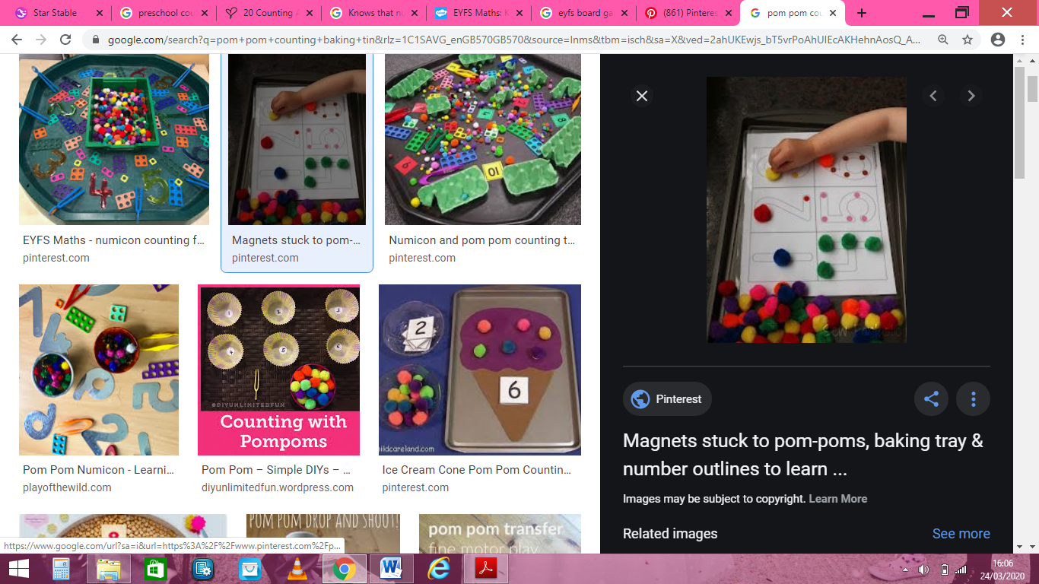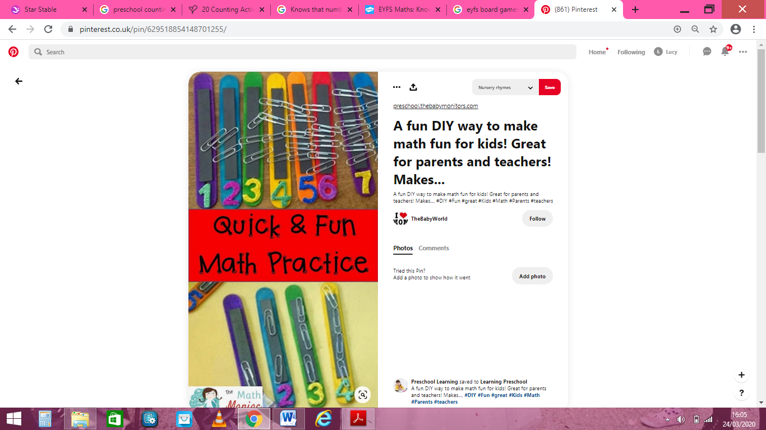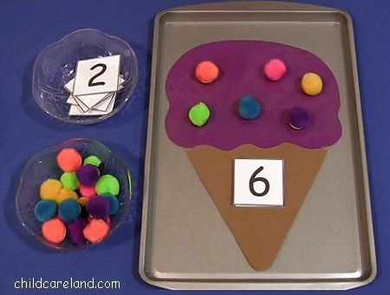

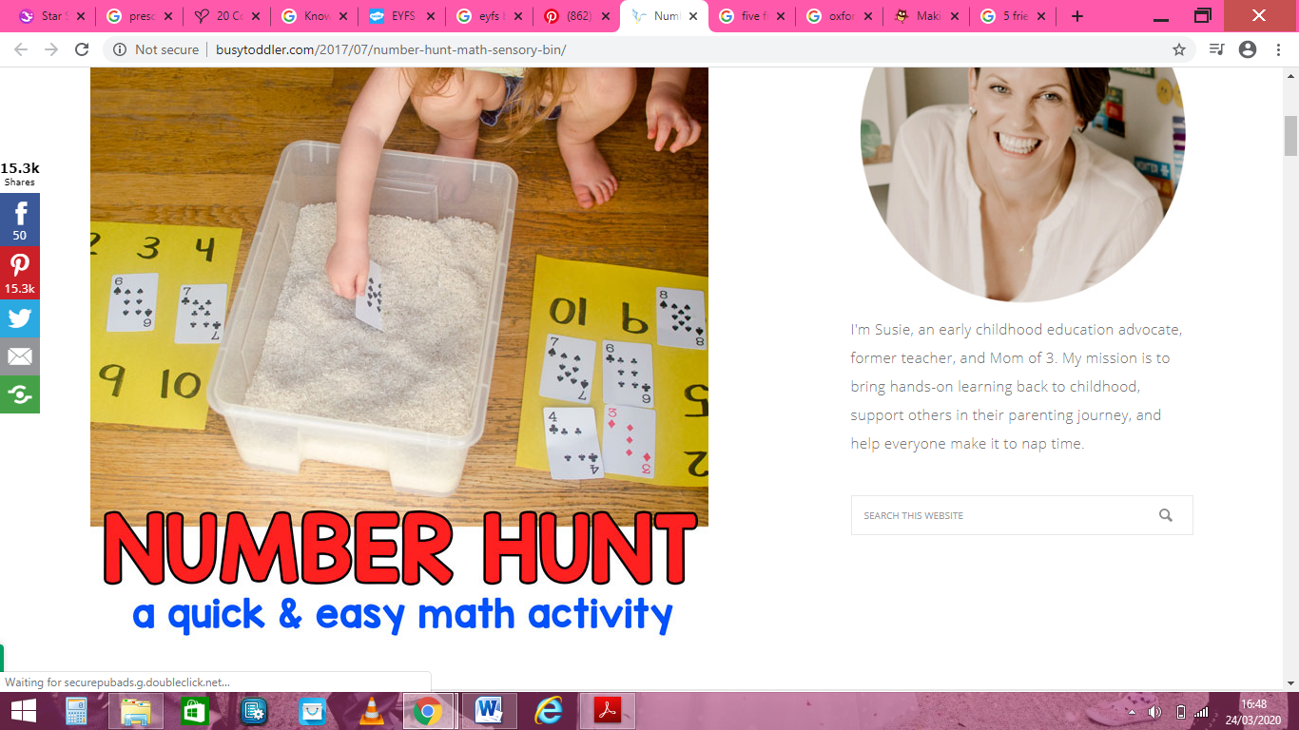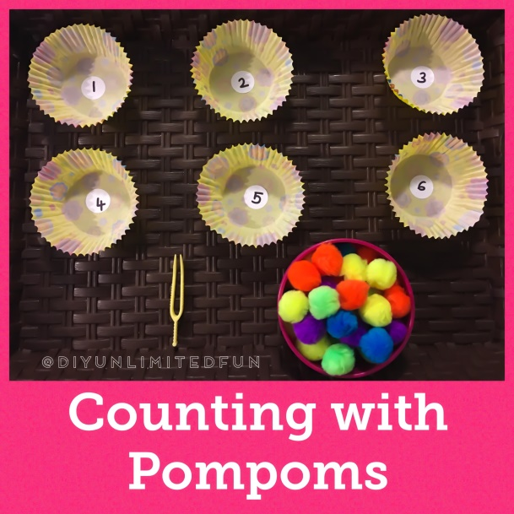

**These activities could help develop**

Counting consistently to 5/10/20

Counting out a set number

Matching number and quantity

Number recognition

Extend this activity

If I had one more how many would I have? If I took one away how many are left? With your 5 pom poms, how many different ways can you share them out between you and me. Number bonds to 5.

**This activity could help develop**

Counting consistently to 5/10/20

Counting out a set number

Matching number and quantity

Number recognition

Understanding how numbers are made by exploring number bonds. Sharing numbers

Representing/ mark making numbers

Extend this activity

If I had one more how many? If I took one away how many are left?

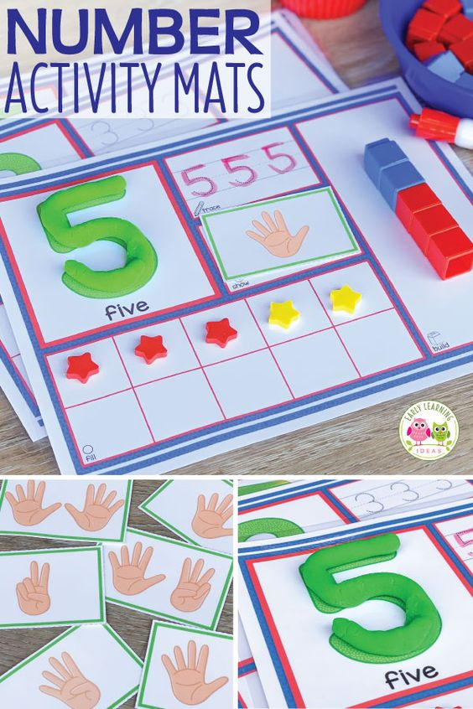**

**Everyday games questions and problem solving**

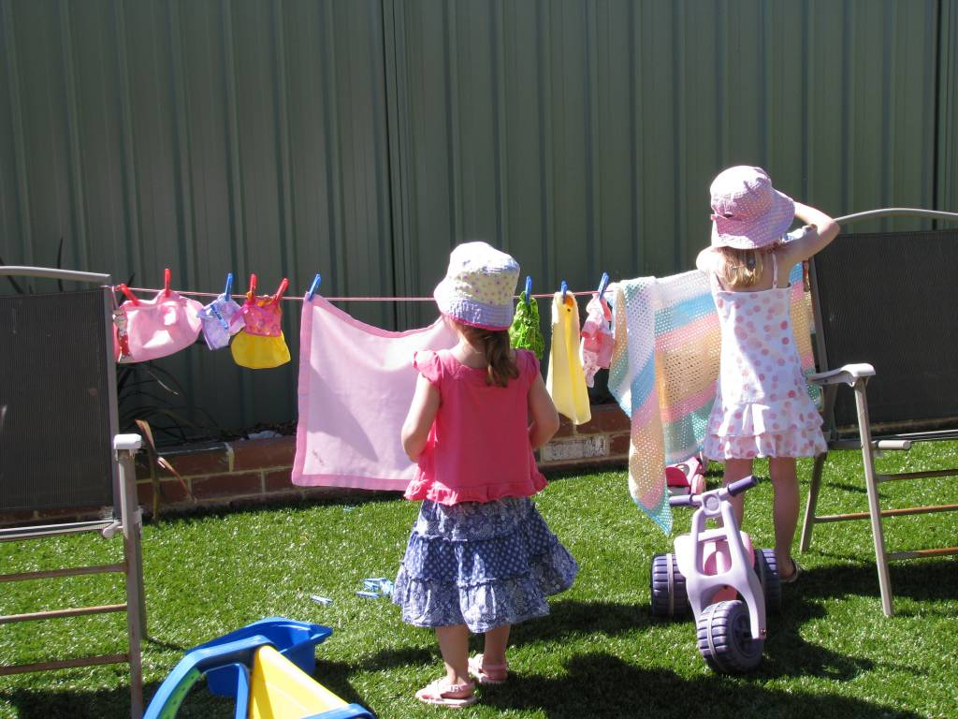

How many items can we fit on the line? Estimate then count to see.

How many t-shirts? How many socks? How many altogether? How many are left? How many are yours/mine? Who has the most? Can we spread them out? Have we still got the same number?

**Counting during snack**

Can you help prepare our lunch?

I have 10 grapes can you share them between the plates? Is it fair? Have we got the same?

Can you put 2 pieces of cheese on each plate?

Can you chop the banana up with me? How many slices did we make?

How many sandwiches have you got?

I had 5 grapes and I have eaten 1 how many are left now?

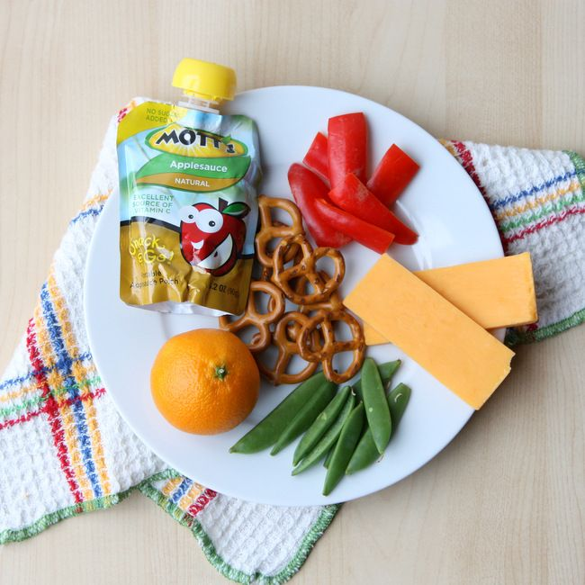

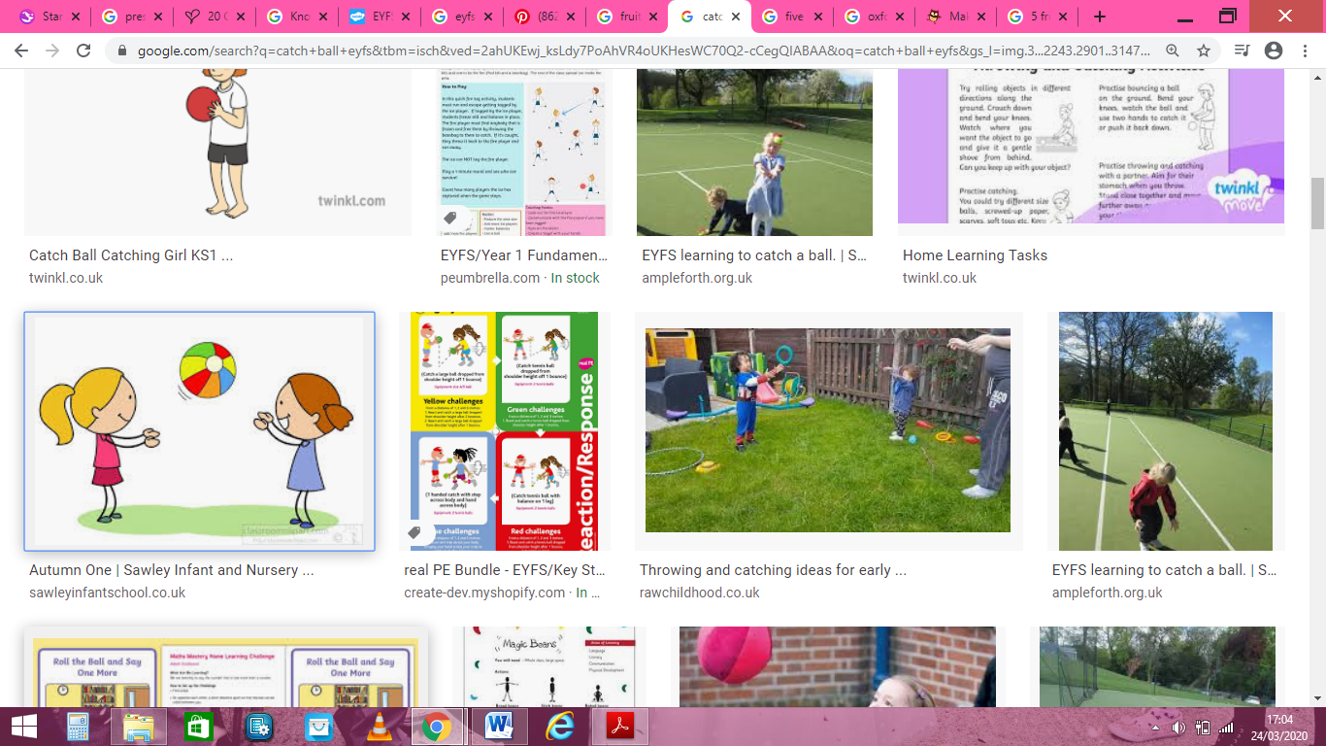

**Games**

How many times can you catch/bounce/roll/kick the ball?

Count how long you can balance on 1 leg. Can you beat your personal best? What’s the longest time you can do it?

Hide and seek

What’s the time Mr Wolf