Below are the Literacy statements we follow in school from Development matters. There are some ideas of how you might like to support your child’s literacy development at home underneath. Reading and writing go hand in hand so a lot of these activities support both areas.

**Reading/ Writing**

**Reception**

Read individual letters by saying the sounds for them.

Blend sounds into words, so that they can read short words made up of known letter-sound correspondences.

Read some letter groups that each represent one sound and say sounds for them.

Read a few common exception words matched to the school’s phonic programme.

Read simple phrases and sentences made up of words with known letter–sound correspondences and, where necessary, a few exception words.

Re-read these books to build up their confidence in word reading, their fluency and their understanding and enjoyment.

Form lower-case and capital letters correctly.

Spell words by identifying the sounds and then writing the sound with letter/s.

Write short sentences with words with known letter-sound correspondences using a capital letter and full stop.

Re-read what they have written to check that it makes sense.

**Nursery**

Understand the five key concepts about print:- print has meaning - the names of the different parts of a book- print can have different purposes - page sequencing- we read English text from left to right and from top to bottom

Develop their phonological awareness, so that they can:- spot and suggest rhymes- count or clap syllables in a word- recognise words with the same initial sound, such as money and mother

Engage in extended conversations about stories, learning new vocabulary.

Use some of their print and letter knowledge in their early writing. For example: writing a pretend shopping list that starts at the top of the page; write ‘m’ for mummy.

Write some or all of their name.

Write some letters accurately.

Maths

Fast recognition of up to 3 objects, without having to count them individually (‘subitising’).

• Recite numbers past 5.

• Say one number for each item in order: 1,2,3,4,5.

• Know that the last number reached when counting a small set of objects tells you how many there are in total (‘cardinal principle’).

• Show ‘finger numbers’ up to 5.

• Link numerals and amounts: for example, showing the right number of objects to match the numeral, up to 5.

Experiment with their own symbols and marks as well as numerals.

Solve real world mathematical problems with numbers up to 5.

Compare quantities using language: ‘more than’, ‘fewer than’.

Talk about and explore 2D and 3D shapes (for example, circles, rectangles, triangles and cuboids) using informal and mathematical language: ‘sides’, ‘corners’; ‘straight’, ‘flat’, ‘round’.

Understand position through words alone – for example, “The bag is under the table,” – with no pointing.

Describe a familiar route.

Discuss routes and locations, using words like ‘in front of’ and ‘behind’.

Make comparisons between objects relating to size, length, weight and capacity.

Select shapes appropriately: flat surfaces for building, a triangular prism for a roof etc.

Combine shapes to make new ones – an arch, a bigger triangle etc.

Talk about and identifies the patterns around them. For example: stripes on clothes, designs on rugs and wallpaper. Use informal language like ‘pointy’, ‘spotty’, ‘blobs’ etc.

Extend and create ABAB patterns – stick, leaf, stick, leaf.

Notice and correct an error in a repeating pattern.

Begin to describe a sequence of events, real or fictional, using words such as ‘first’, ‘then...’

**Mark making**

Giving meaning to marks is where our writing journey begins in Nursery. Allowing children to experiment with different mark making tools is fun and can help engage children who aren’t yet interested in putting pencil to paper. When children mark make it’s important that we give them time to talk about the marks they have made and can give meaning to them by differentiating between the different marks they have made. Eg that’s the sun and that’s the grass…

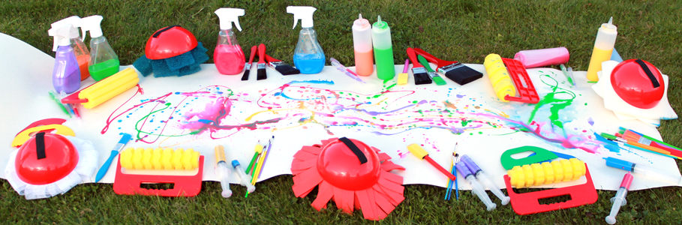

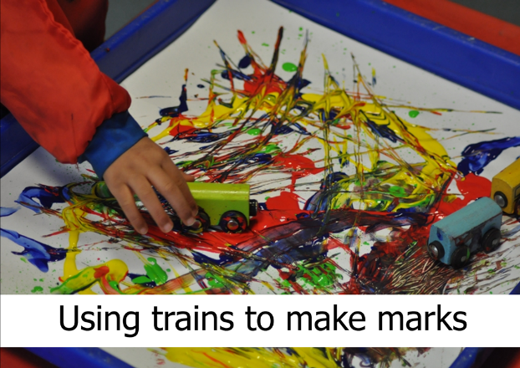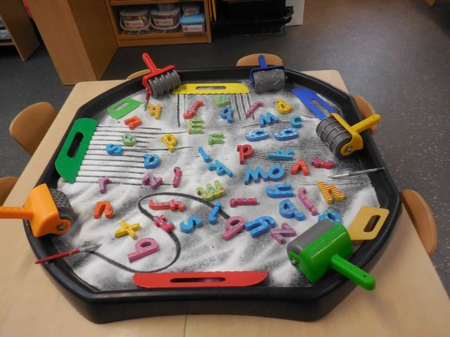

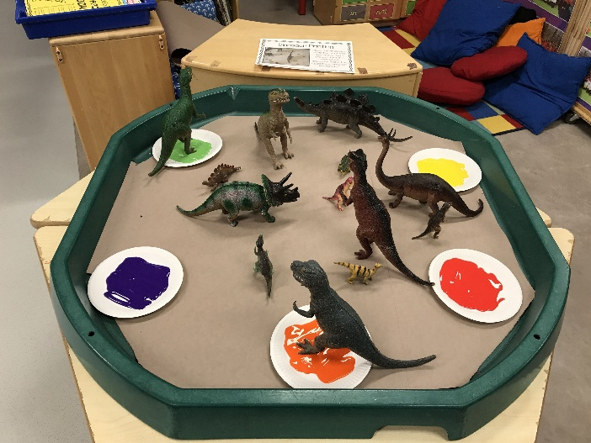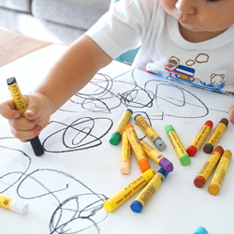

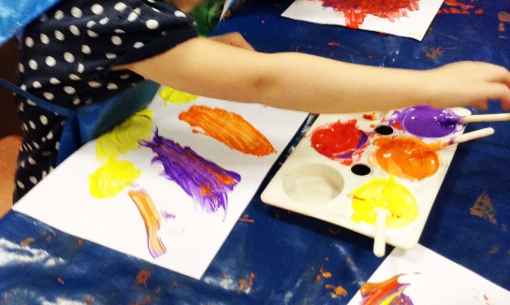

**Mark making during play**

Mark making through play. This helps children make the connection that marks have different meanings and they can write for different reasons too. If you would like some writing templates have a look on <https://www.twinkl.co.uk> and search for EYFS writing templates.  
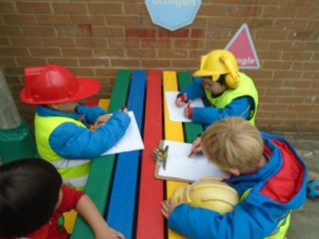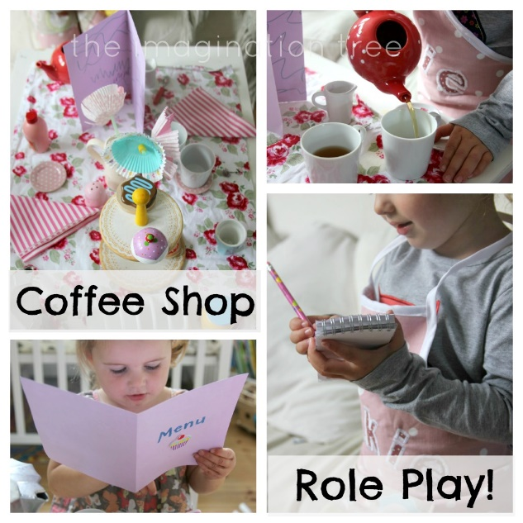

**Designing a build/listing supplies/ writing receipts Taking orders/shopping lists**

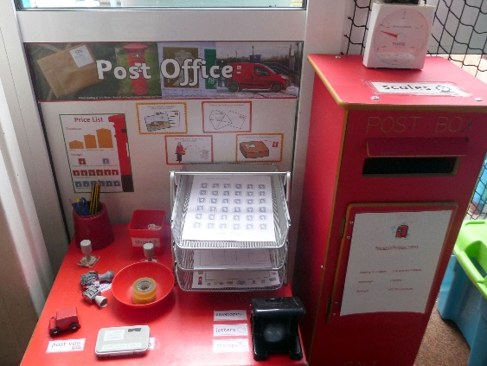 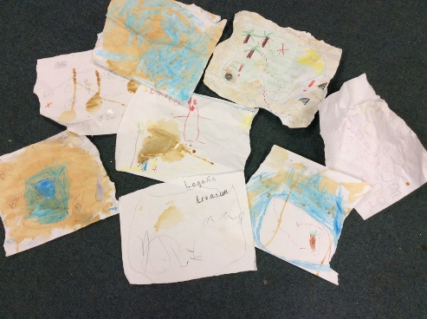

**Treasure Maps/ Wanted posters  
 Writing letters/cards/invitations**

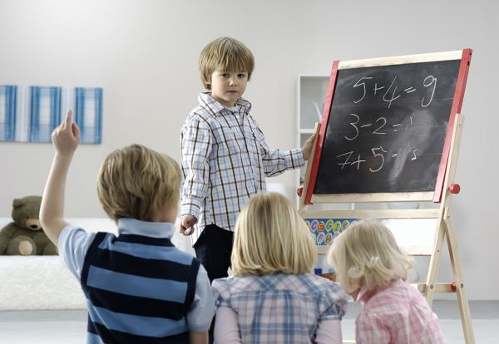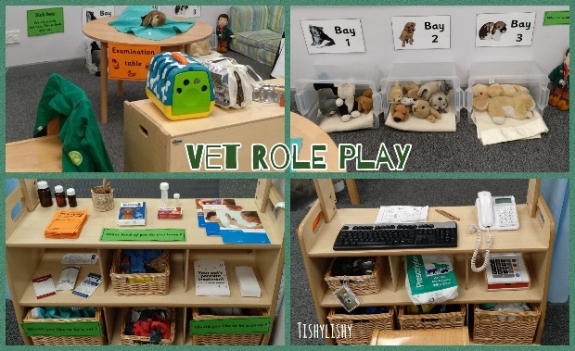

**Taking notes/ phone calls/writing prescriptions/ Playing schools/ taking the register**

**making appointments**

**Writing their name**

We can start by exposing children to their name in lots of different ways. Through play and mark making activities. When children are ready, they will begin to recognise their names and possibly start spotting letters from within their name everywhere “that’s in my name!” Children’s names are special to them and it is probably the first word they will want to write because those marks are personal to them. We can support this through mark making letters from their name in ways that interest them and beginning to trace and copy their names onto cards letters and pictures.

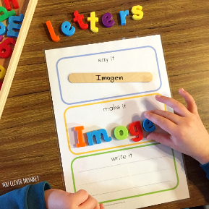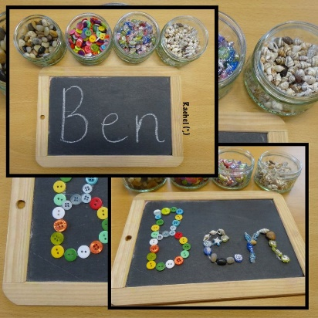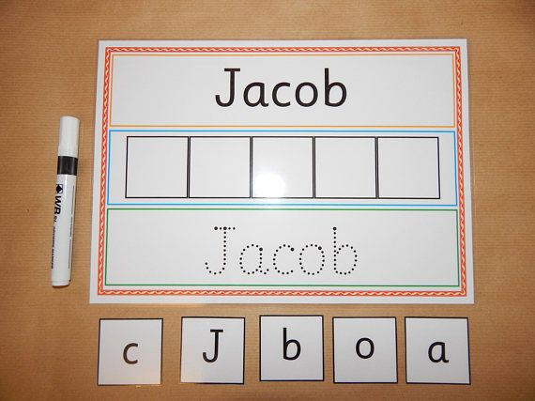

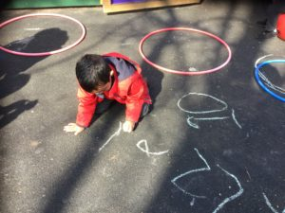

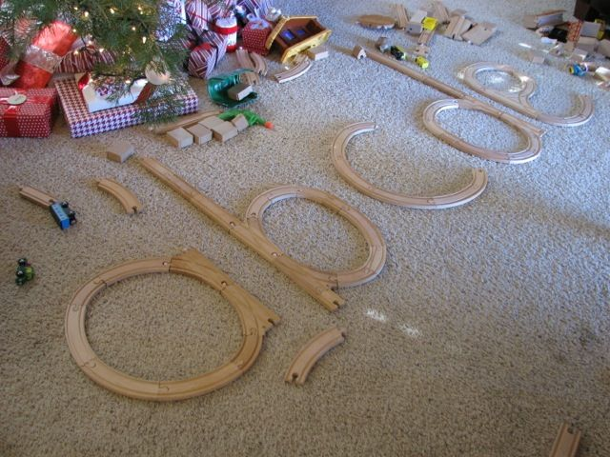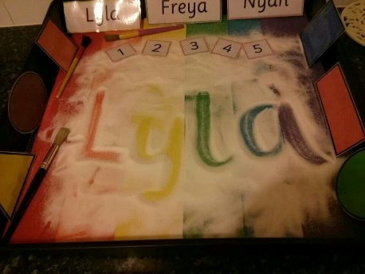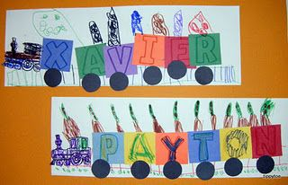

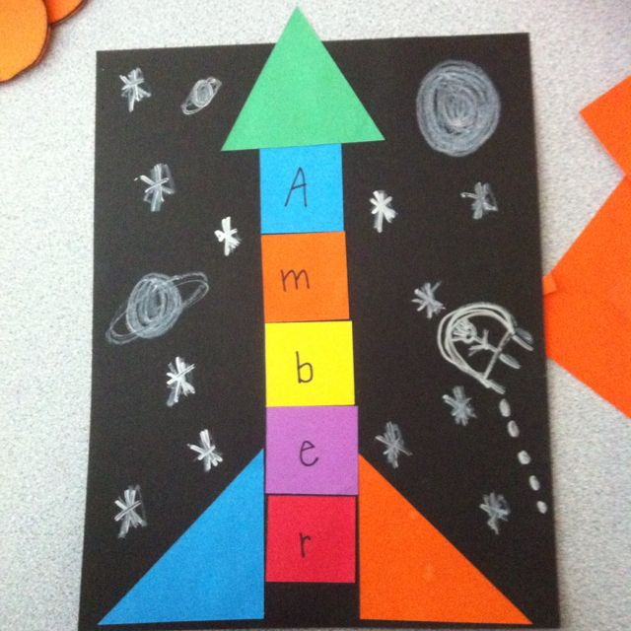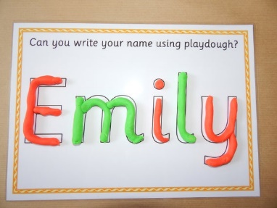

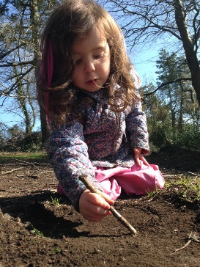

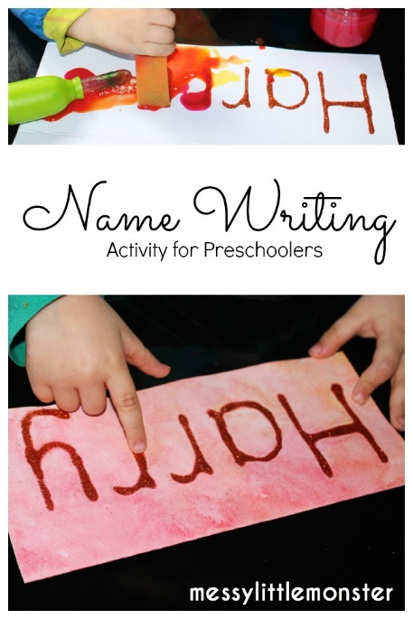

**Starting to write**

Once children know how to write their name they might begin to write the letters out in strings and tell you they say other words. This interest in writing shows us that we can start to introduce them to new letters and sounds and working towards writing simple words.

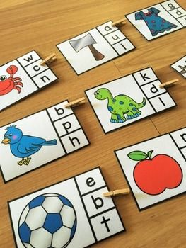

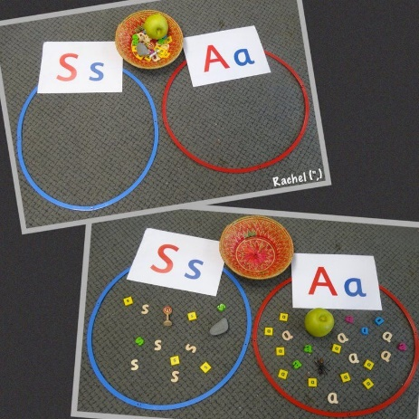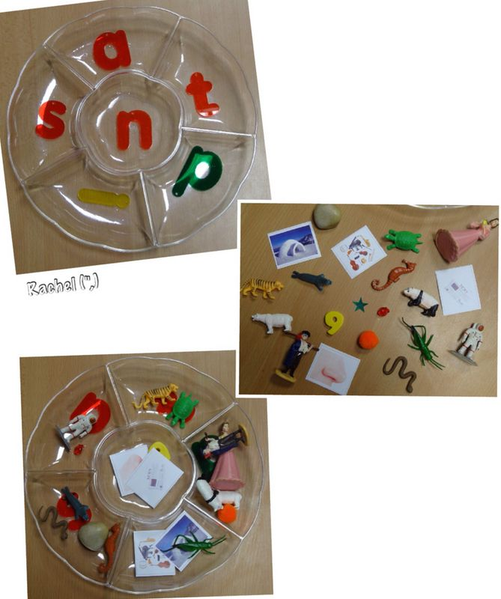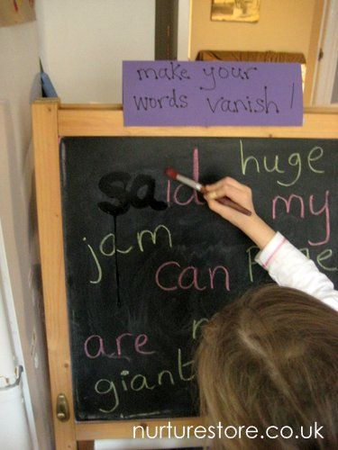

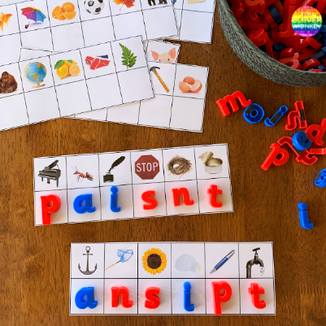

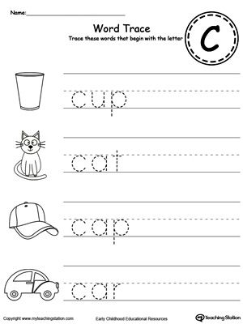

**Phonics activities that help the children to segment and blend (sound out the word and put it back together)**

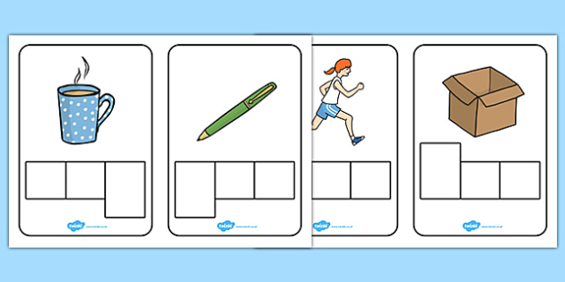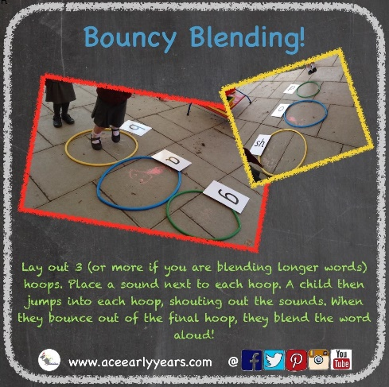

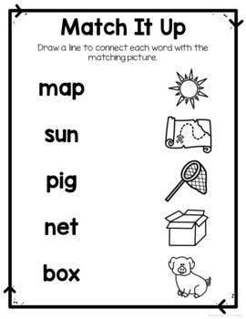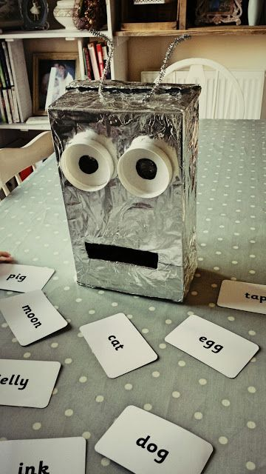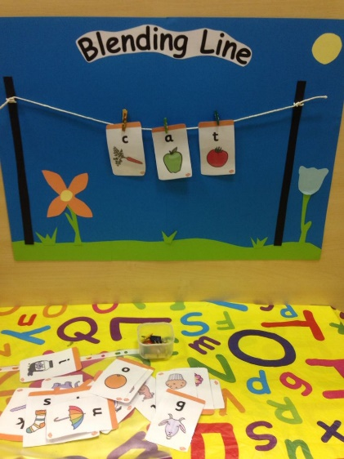

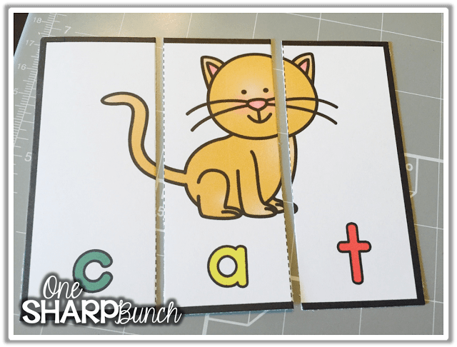

**Phase One Phonics- Early reading**

In school we follow Letters and Sounds Phase One. All of the games help tune into sounds in the environment. These are the skills that will help your child when they start to tune into letter sounds for reading/ writing. Phase One has 7 aspects and we focus on a mixture of Aspect 1-6 each week at school. Only when they have got these skills do we move onto Aspect 7. This is normally in the summer term.

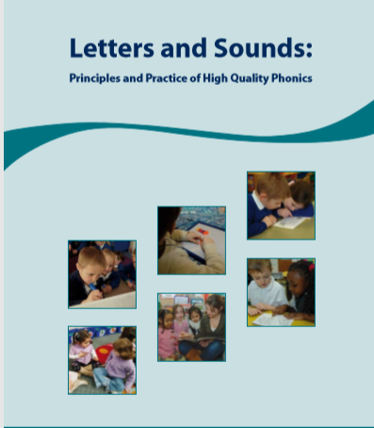**Activities that you can do at home include:**

* Singing Nursery rhymes everyday
* Read to your child everyday
* Allow children time to read their favourite stories
* Encourage them to retell their favourite stories
* Model how to listen and communicate
* Using props and actions to act out nursery rhymes/stories
* Listening to sounds in the environment. Sound walks.
* Copying different rhythms
* Exploring different instrument sounds and natural sounds.

E.g using sticks as drumsticks and exploring different sounds

* Making up silly rhymes
* I spy games
* Making musical shakers
* Body percussion
* Exploring animals sounds and adding sound effects to songs or stories
* 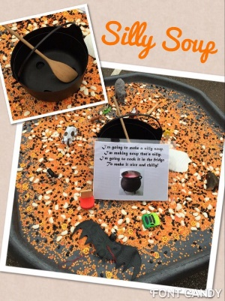Playing rhyming games- spot the odd one out/ silly soup

